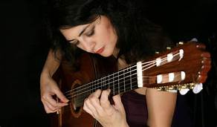
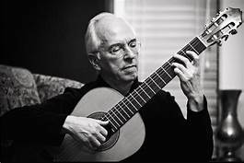

CLASSIC GUITAR SUMMATIVE

- Provide a TITLE PAGE for your assignment. The template is at earlhaig.ca.
- Do not use subtitles for your paragraphs
- Write in essay form: DOUBLE SPACE your writing.
- Write in essay form: INDENT the first line of each paragraph with a <tab> space.
- Use ITALICS for the names of published works: The Concierto de Aranjuez.
- Write a paragraph on each of the following topics as they apply to the classic guitar.
- Write your paragraphs in the order shown in this assignment page:
- Write in your own words. Do not Cut & Paste. Your similarity level must be less than 10% in turnitin.com.

KNOWLEDGE 25%

HISTORY:
Write a brief history of the classic guitar.
Which country or countries did the fore-runner to the classic guitar first appear around the 11th century?
Which culture invented the first four-string guitar-like instrument?
Which culture developed a six-string instrument before the invention of the modern guitar?
What was happening with the guitar in Germany around 1788?
Is it correct to call the classic guitar the “Spanish guitar?”
What are three differences between the construction and playing of the classic guitar as opposed to the plectrum guitar (folk guitar or electric guitar)?

What has happened to the development of classic guitar strings in the 20th century?

THINKING 25%

PERFORMERS:
Identify three famous classical guitarists.
Provide their dates and nationalities.
Where did they do most of their work?
Provide the names of three compositions associated respectively with each performer.
These compositions may have been composed and played by the performer or, they may have been composed by somebody else and performed by the performer.
APPLICATION 25%

A COMPOSITION:
Choose a classical guitar piece that you like the sound of, perhaps from youtube.
Identify the composer. Provide his dates and nationality.
When and where was the composition written and first performed?
Identify the guitarist. Provide his dates and nationality if not supplied in paragraph two.
What appeals to you about the composition you have chosen?

COMMUNICATION 25%

REFLECTION:
Reflect on the value of classic guitar playing style for you.
Can you compare classic style to another guitar playing style, for example plectrum style or Flamenco?
Do you intend to continue with study of the classic guitar, perhaps privately?
Do you intend to continue playing the guitar for your own pleasure?

